Chapter 10
Testing Web Applications
About This Chapter
The goal of testing software is to ensure that the software meets product requirements. Two preconditions lurk in that simple statement:
- Without product requirements, you can’t start testing.
- Without measurable goals, you don’t know when to stop testing.
Product requirements and goals are generally determined outside the development process—usually by customers or management. In this chapter, you’ll learn how to apply product requirements to plan, create, run, and correct problems found by tests.
Before You Begin
To complete this chapter, you must:
- Have access to a Web server—either through a Web hosting service or through your local area network (LAN)—that you can use to test and debug Web applications.
- Have successfully completed and deployed one or more of the sample Web applications in this book.
- Be familiar with a Microsoft Windows scripting language, such as Microsoft VBScript or Microsoft JScript.
- Have installed Microsoft Application Center Test (ACT), included with Microsoft Visual Studio .NET Enterprise Architect Edition. This requirement applies only to the material in this chapter that discusses load testing Web applications.
Lesson 1: Creating Tests
All software intended for public consumption should receive some level of testing. The more complex or widely distributed a piece of software is, the more essential testing is to its success. Without testing, you have no assurance that software will behave as expected. The results in a public environment can be truly embarrassing.
For software, testing almost always means automated testing. Automated tests use a programming language to replay recorded user actions or to simulate the internal use of a component. Automated tests are reproducible (the same test can be run again and again) and measurable (the test either succeeds or fails). These two advantages are key to ensuring that software meets product requirements.
In this lesson, you’ll learn how to write a test plan, how to ensure that the product is thoroughly tested using different types of tests, and how to create different types of tests using Visual Studio .NET.
After this lesson, you will be able to
- Understand a software test plan
- Identify different types of software testing
- Write unit tests for software components
- Create integration tests for completed components
- Explain how a test library can identify regressions
- Use ACT to create Web application load tests
- Test Web applications for different client configurations
Estimated lesson time: 30 minutes
Developing a Test Plan
The first step in testing is developing a test plan based on the product requirements. The test plan is usually a formal document that ensures that the product meets the following standards:
- Is thoroughly tested
Untested code adds an unknown element to the product and increases the risk of product failure.
- Meets product requirements
To meet customer needs, the product must provide the features and behavior described in the product specification. For this reason, product specifications should be clearly written and well understood.
- Does not contain defects
Features must work within established quality standards, and those standards should be clearly stated within the test plan.
Having a test plan helps you avoid ad hoc testing—the kind of testing that relies on the uncoordinated efforts of developers or testers to ensure that code works. The results of ad hoc testing are usually uneven and always unpredictable. A good test plan answers the following questions:
- How are tests written?
Describe the languages and tools used for testing.
- Who is responsible for the testing?
List the teams or individuals who write and perform the tests.
- When are the tests performed?
The testing schedule closely follows the development schedule.
- Where are the tests and how are test results shared?
Tests should be organized so that they can be rerun on a regular basis.
- What is being tested?
Measurable goals with concrete targets let you know when you have achieved success.
Some of these questions might have more than one answer, depending on the type of test. For instance, individual developers are often responsible for writing the first level of tests for their own code, while a separate testing team might be responsible for ensuring that all code works together. The following sections describe the different types of tests and the techniques used with Visual Studio .NET to perform these tests.
Types of Tests
The test plan specifies the different types of tests that will be performed to ensure the that product meets customer requirements and does not contain defects. Table 10-1 describes the most common test types.
Table 10-1. Types of Tests
Test type | Ensures that
Unit test | Each independent piece of code works correctly.
Integration test | All units work together without errors.
Regression test | Newly added features do not introduce errors to other features that are already working.
Load test (also called stress test) | The product continues to work under extreme usage.
Platform test | The product works on all of the target hardware and software platforms.
These test types build on each other, and the tests are usually performed in the order shown in Table 10-1. The testing process follows the flow diagram shown in Figure 10-1.
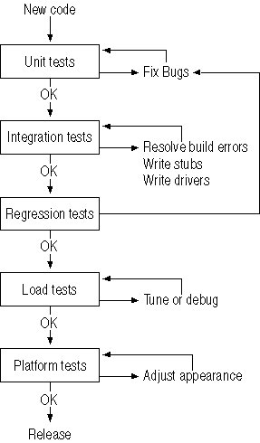
Figure 10-1. The testing cycle
The process shown in Figure 10-1 is based on a modular product design in which the product is developed as a set of components that can be programmed, tested, integrated, and released individually. This is the modern approach, and you should be wary of any project that proposes a monolithic design in which integration and testing are performed only at the end of the development cycle.
Unit Testing
A product unit is the smallest piece of code that can be independently tested. From an object-oriented programming perspective, classes, properties, methods, and events are all individual units. A unit should pass its unit test before it is checked into the project for integration.
Unit tests are commonly written by the developer who programmed the unit and are either written in the same programming language as the product unit being tested or in a similar scripting language, such as VBScript. The unit test itself can be as simple as getting and setting a property value, or it can be more complicated. For instance, a unit test might take sample data and calculate a result and then compare that result against the expected result to check for accuracy.
Group the unit tests together logically. Tests that check each property and method in a class can be included in a single procedure, which is then called from the Sub Main of a separate testing application. For example, the following test procedure creates an instance of the FlashCardClass created in Chapter 2, “Creating Web Forms Applications,” and then tests each of its properties and methods:
Visual Basic .NET
Function TestFlashCard() As Boolean
'Create class.
Dim FlashCard As New MCSDWebAppsVB.FlashCardClass()
'Test if class exists.
If IsNothing(FlashCard) Then
Console.WriteLine("FlashCardClass failed")
'Return False and end here.
Return False
End If
'Test shuffle method using maximum and minimum values.
FlashCard.Shuffle(Integer.MinValue, Integer.MaxValue)
'Test properties.
Dim bResult As Boolean = True
Dim intFirst As Integer = FlashCard.FirstNumber
Dim intSecond As Integer = FlashCard.SecondNumber
Dim dblAnswer As Double = intFirst + intSecond
If dblAnswer <> FlashCard.Answer Then
Console.WriteLine("Error: Numbers don't add up!")
bResult = False
End If
'Shuffle again.
FlashCard.Shuffle(Integer.MinValue, Integer.MaxValue)
'Make sure the new values are unique.
If intFirst = FlashCard.FirstNumber Then
Console.WriteLine("Warning: FirstNumber not unique after shuffle")
End If
If intSecond = FlashCard.SecondNumber Then
Console.WriteLine("Warning: SecondNumber not unique after shuffle")
End If
'Check different operators.
FlashCard.Operation = "-"
If FlashCard.FirstNumber -_
FlashCard.SecondNumber <> FlashCard.Answer Then
Console.WriteLine("Error: - operator doesn't substract.")
bResult = False
End If
FlashCard.Operation = "x"
If FlashCard.FirstNumber * FlashCard.SecondNumber <> FlashCard.Answer Then
Console.WriteLine("Error: x operator doesn't multiply.")
bResult = False
End If
FlashCard.Operation = "+"
If FlashCard.FirstNumber + FlashCard.SecondNumber <> FlashCard.Answer Then
Console.WriteLine("Error: + operator doesn't add.")
bResult = False
End If
'Return success/failure.
Return bResult
End Function
Visual C#
static bool TestFlashCardClass()
{
//Create class.
csFlashCards.FlashCardClass FlashCard = new MCSDWebAppsCS.FlashCardClass();
//Test is class exists.
if (FlashCard == null)
{
Console.WriteLine("FlashCardClass failed");
//Return false and end here.
return false;
}
//Test shuffle method using maximum and minimum values.
FlashCard.Shuffle(int.MinValue, int.MaxValue);
//Test properties.
bool bResult = true;
int intFirst = FlashCard.FirstNumber;
int intSecond = FlashCard.SecondNumber;
double dblAnswer = intFirst + intSecond;
if (dblAnswer != (double)FlashCard.Answer())
{
Console.WriteLine("Error: Numbers don't add up!");
bResult = false;
}
//Shuffle again.
FlashCard.Shuffle(int.MinValue, int.MaxValue);
//Make sure new values unique.
if (intFirst == FlashCard.FirstNumber)
Console.WriteLine("Warning: FirstNumber not unique after shuffle");
if (intSecond == FlashCard.SecondNumber)
Console.WriteLine("Warning: SecondNumber not unique after shuffle");
//Check different operators.
FlashCard.Operation = "-";
if (FlashCard.FirstNumber - FlashCard.SecondNumber != FlashCard.Answer())
{
Console.WriteLine("Error: - operator doesn't substract.");
bResult = false;
}
FlashCard.Operation = "x";
if (FlashCard.FirstNumber * FlashCard.SecondNumber != FlashCard.Answer())
{
Console.WriteLine("Error: x operator doesn't multiply.");
bResult = false;
}
FlashCard.Operation = "+";
if (FlashCard.FirstNumber + FlashCard.SecondNumber != FlashCard.Answer())
{
Console.WriteLine("Error: + operator doesn't add.");
bResult = false;
}
//Return success/failure.
return bResult;
}
The most important factor in a unit test is thoroughness. Unit tests should exercise each piece of code in the application and use a range of possible values. The preceding sample demonstrates using a wide range by passing the integer MinValue and MaxValue properties to the Shuffle method.
The tests should report errors at the unit level so that locating and fixing problems is straightforward. The preceding sample does this by displaying a message in the Output window using Console.WriteLine. Alternatively, you can write errors to a testing log file using Debug.WriteLine or raise alerts using Debug.Assert.
Integration Testing
The first integration test always answers the question, “Does the application compile?” At this point, a compilation error in any of the components can keep the integration testing from moving forward. Some projects use nightly builds to ensure that the product will always compile. If the build fails, the problem can be quickly resolved the next morning.
The most common build problem occurs when one component tries to use another component that has not yet been written. This occurs with modular design because the components are often created out of sequence. You solve this problem by creating stubs. Stubs are nonfunctional components that provide the class, property, or method definition used by the other component. Stubs are a kind of outline of the code you will create later.
When all of the build problems are resolved, integration testing really becomes just an extension of unit testing, although the focus is now whether the units work together. At this point, it is possible to wind up with two components that need to work together through a third component that has not been written yet. To test these two components, you create a driver. Drivers are simply test components that make sure two or more components work together. Later in the project, testing performed by the driver can be performed by the actual component.
In addition to adding stubs and drivers to your application, you might need to add a testing interface to help automate the integration testing of some components. A testing interface is a set of public properties and methods or other tools that you can use to control a component from an external testing program. For example, the following testing interface generates a log of the results displayed by the FlashCard application’s Web form:
Visual Basic .NET
' From FlashCards.aspx
Private Sub txtAnswer_TextChanged(ByVal sender As System.Object, _
ByVal e As System.EventArgs) Handles txtAnswer.TextChanged
If txtAnswer.Text = FlashCard.Answer Then
lblFeedback.Text = "Correct!"
#If DEBUG Then
LogResult()
#End If
' Get another set of numbers.
FlashCard.Shuffle()
' Refresh display to show new numbers.
RefreshDisplay()
Else
lblFeedback.Text = "Oops! Try Again."
#If DEBUG Then
LogResult()
#End If
End If
' Clear answer
txtAnswer.Text = ""
End Sub

#If DEBUG Then
Public Sub TestUI()
Dim strResult As String
' Check if correct.
If lblFeedback.Text = "Correct!" Then
strResult = lblFirst.Text + lblSecond.Text + "=" + txtAnswer.Text
Else
strResult = lblFirst.Text + lblSecond.Text + "!=" + txtAnswer.Text
End If
Dim filResult As StreamWriter = _
File.AppendText(Server.MapPath(".\results.log"))
filResult.Write(System.DateTime.Now.ToString() + ", ")
filResult.WriteLine(strResult)
filResult.Close()
End Sub
#End If
Visual C#
//From FlashCards.aspx
private void txtAnswer_TextChanged(object sender, System.EventArgs e)
{
if(txtAnswer.Text == FlashCard.Answer().ToString())
{
lblFeedback.Text = "Correct!";
#if DEBUG
TestUI();
#endif
//Get another set of numbers.
FlashCard.Shuffle();
//Refresh display to show new numbers.
RefreshDisplay();
//Clear answer
txtAnswer.Text = "";
}
else
{
lblFeedback.Text = "Oops! Try Again.";
#if DEBUG
TestUI();
#endif
}
}

#if DEBUG
public void TestUI()
{
string strResult;
//Check if correct.
if (lblFeedback.Text == "Correct!")
strResult = lblFirst.Text + lblSecond.Text + "=" + txtAnswer.Text;
else
strResult = lblFirst.Text + lblSecond.Text + "!=" + txtAnswer.Text;
StreamWriter filResult =
File.AppendText(Server.MapPath(".\\results.log"));
filResult.Write(System.DateTime.Now.ToString() + ", ");
filResult.WriteLine(strResult);
filResult.Close();
}
#endif
The preceding code uses the #If…#End If/#if…#endif preprocessor directives to prevent the testing interface from being compiled into the release version of the product. This is important because a testing interface exposes the inner workings of the application, which you generally want to hide in the final version.
Regression Testing
Unit and integration tests form the basis of regression testing. As each test is written and passed, it gets checked into the test library for a regularly scheduled testing run. If a new component or a change to an existing component breaks one of the existing unit or integration tests, the error is called a regression.
If you design your test properly, the unit and integration tests report their errors in a way that makes it easy to locate the cause of the regression. If the test doesn’t provide an easy way to locate the cause, you might need to improve those tests or you might need to write new tests to target the regression.
The key to success with both integration and regression testing is to run the full set of tests frequently—if possible, as part of the nightly build. Detecting problems early and resolving them as they occur prevents one error from hiding others.
Load Testing
When you deploy a Web application, it might be used by one or two clients at a time or it might get deluged by thousands of requests. To find out how well a Web application will work in these varying conditions, you need to perform load tests. Use the Microsoft ACT to create and run load tests on a Web application.
To use ACT, follow these steps:
- Create a test by recording a user session with the Web application using ACT.
- Set the load level and duration properties for the test.
- Run the test.
In general, load tests are not created as early in the development process or run as frequently as unit, integration, or regression tests. The following sections describe how to create and run load tests in more detail.
Recording a Load Test
To record a load test in ACT, follow these steps:
- From the ACT Actions menu, choose New Test. ACT displays the New Test Wizard.
- Click Next. The wizard displays the Test Source page, as shown in Figure 10-2.
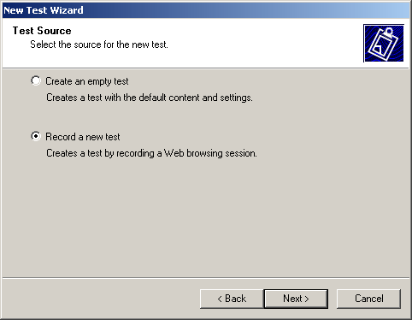
Figure 10-2. Recording a new load test
- Select Record A New Test, and click Next. The wizard displays the Test Type page, as shown in Figure 10-3.
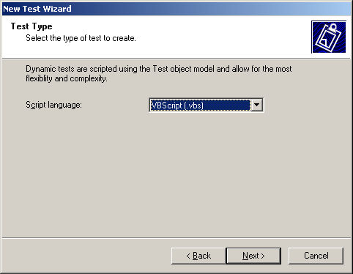
Figure 10-3. Selecting a language
- Click Next. The wizard displays the Browser Record page, as shown in Figure 10-4.
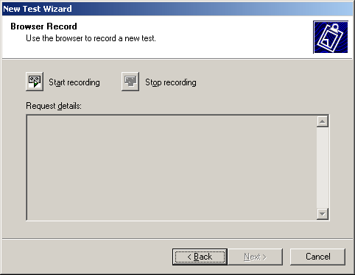
Figure 10-4. Starting and stopping recording
- Click Start Recording. The wizard displays a browser window, as shown in Figure 10-5.
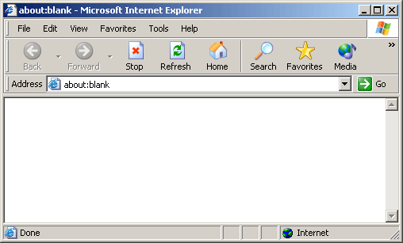
Figure 10-5. Performing actions to record
- Perform the actions you want to record. For instance, you might walk through all the pages in your Web application, performing tasks on each page.
- On the Browser Record page, click Stop Recording when you have finished recording actions, and then click Next. The wizard displays the Test Properties page, as shown in Figure 10-6.
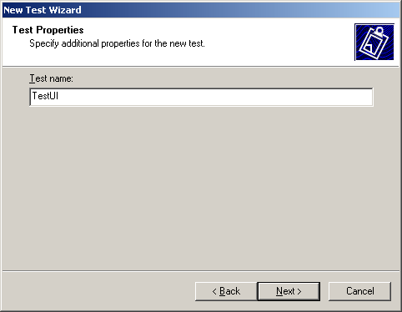
Figure 10-6. Naming the test
- Enter a name for the test, and click Next. The wizard displays the Completing The New Test Wizard page. Click Finish to close the wizard.
Setting Test Properties
After you record a test, it is displayed in the Tests list in ACT, as shown in Figure 10-7.
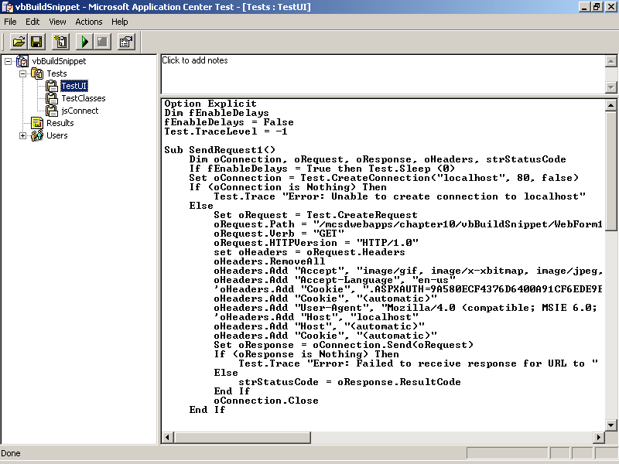
Figure 10-7. The recorded test
ACT tests can be written in the VBScript or JScript languages, but ACT records tests using VBScript only. After you record a test, set the load and duration of the test by following these steps:
- Right-click your test, and choose Properties on the shortcut menu. ACT displays the test’s load and duration properties, as shown in Figure 10-8.
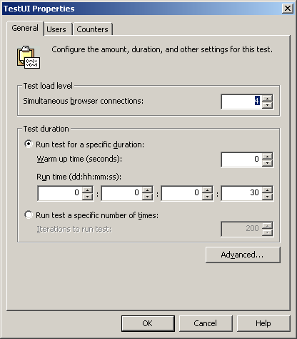
Figure 10-8. Test load and duration
- Set the Test load level to increase the number of users accessing the Web application at the same time. Set the Test duration to run the test for a certain amount of time or for a certain number of requests. Click OK when you’ve finished.
Running Load Tests
To run a load test in ACT, select the test, and then choose Start Test from the Actions menu. ACT displays the Test Status dialog box, as shown in Figure 10-9.
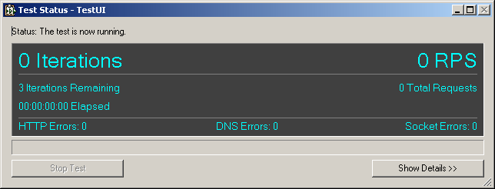
Figure 10-9. The Test Status dialog box
Running tests with ACT and analyzing their results is covered in more detail in Lesson 2.
Platform Testing
For Web applications, platform testing usually means verifying four main conditions:
- Web forms are displayed correctly on all supported browsers and supported versions of those browsers.
- The Web application appropriately handles unsupported browser versions—for example, by displaying instructions for downloading the required version.
- The client is prompted to install any required components, such as Microsoft ActiveX objects or plug-ins, if they are not already installed on his or her computer.
- The Web application has acceptable performance over slower forms of network connections, such as modems.
To run platform tests, you need to set up a platform lab that contains computers representing the different hardware and software configurations that your application supports, as shown in Figure 10-10.
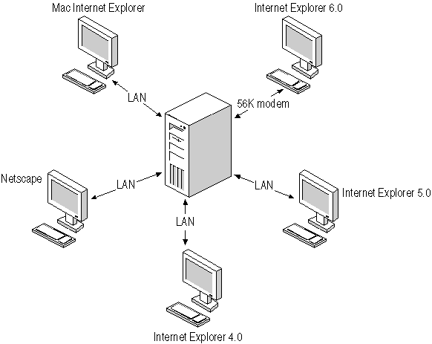
Figure 10-10. Platform testing lab
Verifying that each Web form is displayed correctly requires some human intervention. ASP.NET renders server controls differently on different browsers, so you should visually inspect your Web application as part of the final testing cycle.
Lesson 2: Running Tests
In the preceding lesson, you learned how to plan testing and how to create different types of tests using Visual Studio .NET. In this lesson, you’ll learn how to run those tests and capture their results.
After this lesson, you will be able to
- Use ACT to run load tests on Web applications
- Record results and performance data from a load test
- Mimic different browser types with ACT and check browser responses for contained strings within test scripts
- Use the Windows Scripting Host to test .NET assemblies
- Create command files to build and test .NET assemblies
- Run command files at specified times using the Windows Task Manager to perform unattended nightly build and test runs
Estimated lesson time: 30 minutes
Running Tests with ACT
Lesson 1 briefly showed you how to create a load test and run it in ACT. This section describes how to configure and run ACT tests in more detail by describing how to perform the following tasks:
- Log test results.
- Configure the test to use multiple simultaneous connections.
- Run tests with different user name and password combinations.
- Add performance counters to a test.
- Mimic different browsers and different network connection types.
These tasks are explained in the following sections.
Logging Test Results
By default, ACT creates a log file for each test project in the /Perflogs folder on the drive where ACT is installed.
To change the location where ACT stores the log file, follow these steps:
- Right-click the project item in the left pane of the ACT window, and choose Properties from the shortcut menu. ACT displays the test project’s Properties dialog box, as shown in Figure 10-11.
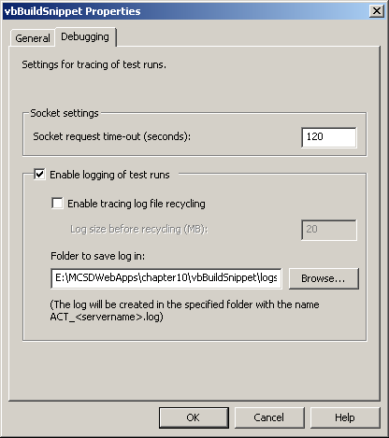
Figure 10-11. Setting log file location
- Click the Debugging tab, and enter a location for storing test project logs in the Folder To Save Log In box. Click OK when you’ve finished.
ACT log files record different amounts of information, depending on the test’s TraceLevel settings. To change the amount of information logged, set the Test object’s TraceLevel property within a test script. For example, the following line of script tells ACT to log all messages:
VBScript
Test.TraceLevel = -1
JScript
Test.TraceLevel = -1;
The TraceLevel property has the settings shown in Table 10-2.
Table 10-2. TraceLevel Settings
Setting | Logs
-1 | All information, including requests sent to the application, responses from the application, and messages written by Trace methods in the test script.
0 | No information—turns off logging.
1 | Requests sent to the application and responses from the application.
2 | Messages written by Trace methods in the test script. This is the default setting.
Use the Test object’s Trace method to write messages to the log from within the test script. For example, the following script writes a message to the log if ACT is not able to connect to the server:
VBScript
Dim g_oConnection

ConnnectToServer

Sub ConnectToServer()
Set g_oConnection = Test.CreateConnection("http://www.contoso.com, 80, false)
If (g_oConnection is Nothing) Then
Test.Trace "Error: Unable to create connection to contoso"
End If
End Sub
JScript
var g_oConnection

ConnectToServer();

function ConnectToServer()
{
g_oConnection = Test.CreateConnection
("http://www.contoso.com", 80, false);
if (g_oConnection == null)
Test.Trace("Error: Unable to create connection to contoso");
}
Using Multiple Connections
ACT can simulate different server load levels by adding simultaneous connections to use during the test. By default, ACT uses one connection to send requests to the Web application. Additional connections are the equivalent of additional simultaneous users.
To increase the number of connections used for a test, follow these steps:
- Right-click the test item in the left pane of the ACT window, and choose Properties from the shortcut menu. ACT displays the test’s Properties dialog box, as shown in Figure 10-12.
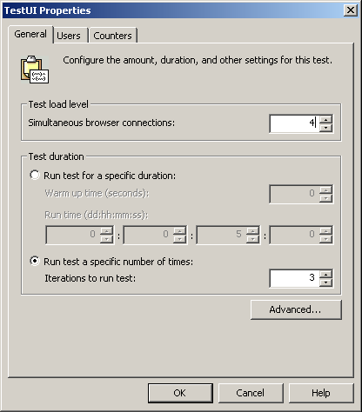
Figure 10-12. Test properties
- Change the number in the Test Load Level section to set the number of simultaneous connections. Click OK when you’ve finished.
Adding Users and Passwords
ACT can supply user names and passwords to a Web application through the user’s groups stored with the test project. This allows you to test how a Web application authenticates users and also permits you to test cookies.
To add user names and passwords to a user group, follow these steps:
- Select Users in the left pane of the ACT window to expand the list of user groups.
- Select a user group, and then enter user names and passwords in the table displayed in the right pane of the ACT window. Figure 10-13 shows changes to the Default Users Group.
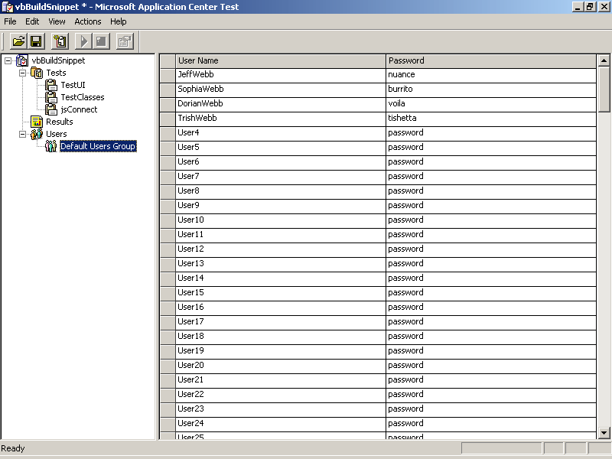
Figure 10-13. Adding users
- Right-click the test item in the left pane of the ACT window, and select Properties. ACT displays the test’s Properties dialog box, as shown in Figure 10-14.
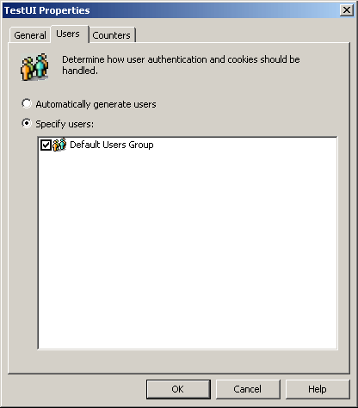
Figure 10-14. Setting test properties to activate users
- Click the Users tab, and select Specify Users. Click OK when you’ve finished.
ACT automatically changes users for each new iteration of a test and for each new connection it creates. You can also manually change users within a test using the Test object’s GetNextUser method, as shown here:
VBScript
Sub ChangeUser()
Test.GetNextUser
Test.Trace("Next user name: " & Test.GetCurrentUser.Name)
End Sub
JScript
function ChangeUser()
{
Test.GetNextUser();
Test.Trace("Next user name: " + Test.GetCurrentUser.Name);
}
Adding Performance Counters
You can track a Web application’s performance during a load test by adding performance counters to the test’s properties. These performance counters are the same ones that you used to monitor server performance in Chapter 9, “Building and Deploying Web Applications,” using the Microsoft Management Console (MMC) Performance Logs and Alerts snap-in.
To add performance counters to a load test, follow these steps:
- Right-click the test item in the left pane of the ACT window, and choose Properties on the shortcut menu. ACT displays the test’s Properties dialog box.
- Click the Counters tab, and then click Add. ACT displays the Browse Performance Counters dialog box, as shown in Figure 10-15.
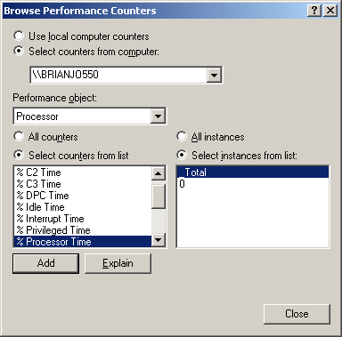
Figure 10-15. Adding counters
- Select the counters you want to monitor, and click Add. Click Close when you have finished adding counters.
- Click OK to close the test’s Properties dialog box.
When a test runs, ACT saves performance statistics in an XML file that is listed in the test results pane of the ACT window, as shown in Figure 10-16.
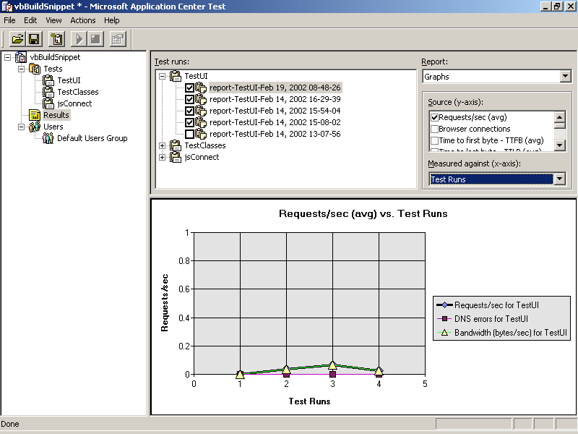
Figure 10-16. Viewing performance results
Mimicking Browser Types
ACT can mimic different types of browsers by modifying the user agent information included in the header it sends with each request. The Browser Type test in the ACTSamples project that is installed with ACT demonstrates how to do this.
You can copy the Browser Type test to your own test projects to test browser compatibility and to test whether your application responds correctly to unsupported browser types. Because ACT does not actually display the responses, however, you can’t rely on this test to visually check that your Web application is displayed correctly on different browsers.
Getting Content of Responses
ACT returns the server’s response to a request as the Response object’s Body property. You can use the VBScript Instr function to test whether a response contains an expected result, as shown here:
VBScript
Set oResponse = oConnection.Send(oRequest)
If Instr(oResponse.Body, "Correct!") Then
Test.Trace("Correct response.")
Else
Test.Trace("Incorrect response.")
End If
JScript
oResponse = oConnection.Send(oRequest);
if (oResponse.Body.search"Correct!"))
Test.Trace("Correct response.");
else
Test.Trace("Incorrect response.");
The Body Search test in the ACTSamples project further demonstrates using Instr to locate items in a response.
More Info
The ACT online Help provides a complete reference to the testing object model and includes conceptual information about using ACT to load test Web applications.
Running Tests with .NET Assemblies
ACT was written primarily to interact with Web applications through requests and responses. This is great for testing the user interface aspects of a Web application, but it is limiting when you’re trying to perform tests on the underlying classes used by the application.
For example, say that you want to use ACT to test the FlashCardClass, as shown in the section “Unit Testing,” in Lesson 1. How would you do it? Probably by attempting something like this:
VBScript
Test.TraceLevel = -1

Dim FlashCard
Set FlashCard = CreateObject("vbFlashCards.FlashCardClass")

If (FlashCard Is Nothing) Then
Test.Trace("Error: FlashCard not created.")
Test.StopTest
End If
JScript
Test.TraceLevel = -1;

var FlashCard;
FlashCard = CreateObject("csFlashCards.FlashCardClass");

if (FlashCard == null)
{
Test.Trace("Error: FlashCard not created.");
Test.StopTest();
}
The only problem is that this doesn’t work! Because Web applications are based on the Microsoft .NET Framework, you can’t use their namespaces as an argument to the CreateObject method. CreateObject expects a Component Object Model (COM) object’s programmatic identifier (progID), not a namespace.
To use scripting to test a .NET assembly, follow these steps:
- In order to register a .NET assembly for use from COM, the assembly must be compiled as a separate class library. Web application assemblies can’t be used from COM. Register the .NET assembly for use with COM.
- Make sure that the COM application can find the .NET assembly.
- Create the .NET object using the progID registered for the .NET assembly.
The following sections describe these steps in more detail.
Registering .NET Assemblies
Use the RegAsm.exe utility to register a .NET assembly with the system registration database. The RegAsm.exe utility is installed with the .NET Framework.
To use the RegAsm.exe utility, follow these steps:
- Open a Visual Studio .NET command prompt. From the Start menu, point to All Programs, Microsoft Visual Studio .NET, Visual Studio .NET Tools, and then choose Visual Studio .NET Command Prompt.
- Within the command prompt, navigate to the folder containing the assembly to register, and run the following command:
RegAsm.exe assembly.dll
The variable assembly.dll is the name of the assembly to register.
RegAsm.exe registers the public classes from the .NET assembly using their namespace and class names as their progIDs. For example, registering the Shapes assembly created for COM interoperation in Chapter 7, “Advanced Web Forms Programming,” results in the registry entries shown in Figure 10-17.
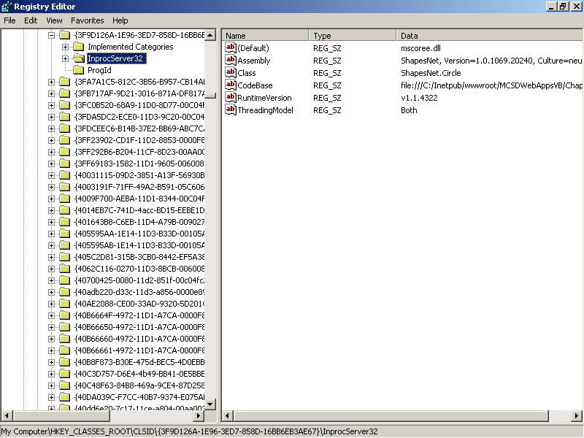
Figure 10-17. Shapes system registration database entries
Locating the .NET Assembly
After you register a .NET assembly, COM components need a way to find the assembly. There are a number of ways to do this, but the three simplest ways are:
- Install the assembly in the global assembly cache (GAC).
- Copy the assembly to the same folder as the COM component that will use it.
- Copy the COM component to the folder where the assembly resides.
Assemblies installed in the GAC are available to all applications on the computer. Assemblies must be configured to use strong names before they can be installed in the GAC. For complete instructions on configuring and installing assemblies in the GAC, see the Visual Studio .NET online Help.
For assemblies that are not intended for sharing with other applications, copying the assembly or the COM component to the same folder might be the easiest solution. This is particularly true for testing, when you might not want an assembly to be generally available.
Creating the .NET Object
After you have registered a .NET assembly and made sure that the COM components can find it, you can create an instance of the .NET object using the COM object creation methods, such as the VBScript CreateObject function.
To see how this works with a testing tool such as the Windows Scripting Host, follow these steps:
- Register a Web application’s assembly as described in the section “Registering .NET Assemblies,” earlier in this chapter.
- Copy CScript.exe from the \Windows\system32 or \WINNT\system32 folder to the Web application’s \bin folder. This is the copy of CScript.exe that you will use to run your testing script; it must be in the same folder as the .NET assembly so that the COM and .NET objects can interoperate.
- Create a VBScript or JScript file, and run it using the copy of CScript.exe stored in the \bin folder.
The following code demonstrates how to test FlashCardClass using the Windows Scripting Host:
VBScript
' TestFlash.vbs
' FlashCardClass unit test
Option Explicit

Dim FlashClass

Set FlashClass = CreateObject("vbFlashCards.FlashCardClass")
' Check if class created.
If (FlashClass is Nothing) Then
WScript.Echo "Error: FlashCardClass not created."
WScript.Quit
End If
' Test Shuffle
FlashClass.Shuffle 1, 1000
Dim X, Y
x = FlashClass.FirstNumber
y = FlashClass.SecondNumber
' Shuffle again
FlashClass.Shuffle 1, 1000
If (x = FlashClass.FirstNumber) or (y = FlashClass.SecondNumber) Then
WScript.Echo "Warning: Number not unique."
End If
' Test Answer
If (FlashClass.FirstNumber + FlashClass.SecondNumber = FlashClass.Answer) Then
WScript.Echo "Success: Answer adds up!"
Else
WScript.Echo "Error: Answer incorrect."
End If
JScript
//TestFlash.js
//FlashCardClass unit test
var FlashClass;

FlashClass = new ActiveXObject("vbFlashCards.FlashCardClass");
//Check if class created.
if (FlashClass == null)
{
WScript.Echo("Error: FlashCardClass not created.");
WScript.Quit();
}
//Test Shuffle
FlashClass.Shuffle(1, 1000);
var X, Y;
x = FlashClass.FirstNumber;
y = FlashClass.SecondNumber;
//Shuffle again
FlashClass.Shuffle(1, 1000);
if ((x == FlashClass.FirstNumber) ││ (y == FlashClass.SecondNumber))
WScript.Echo("Warning: Number not unique.");
//Test Answer
if (FlashClass.FirstNumber + FlashClass.SecondNumber == FlashClass.Answer())
WScript.Echo("Success: Answer adds up!");
else
WScript.Echo("Error: Answer incorrect.");
To run the preceding script, use a command line similar to the following:
@rem VBScript
bin\cscript TestFlash.vbs > logs\FlashErr.log

@rem JScript
bin\cscript TestFlash.js > logs\FlashErr.log
Running Unattended Builds and Tests
Running unit, integration, and load tests on a regular basis provides constant quality assurance and checks for regressions. Most development teams run builds and a set of tests nightly. Running the tests at night prevents conflicts with check-ins and doesn’t disrupt workflow while a machine is tied up doing a build. Because they run late at night, these builds are usually unattended, meaning that no one has to be there to start them or monitor their progress.
To run unattended builds and tests, follow these steps:
- Create a command file to set the environment variables, build, and test commands you want to run.
- Use the Windows Task Manager to schedule the command file to be run.
- Monitor the log files written by the commands to ensure that the builds and tests are succeeding.
The following sections describe these steps in more detail.
Creating a Command File
You can create a command file (.bat) to execute any set of commands you want to run. In general, the command file has three main sections that perform the following tasks:
- Set environment variables, such as PATH and LIB, that are required to find the components used by the build
- Run the Visual Studio .NET development environment to build the assembly
- Run the test tools used to test the assembly
The environment variables used by Visual Studio .NET can be found in the VsVars32.bat command file that is installed in Visual Studio .NET’s Command\Tools folder. You can cut and paste the settings from this file to your command file.
To run Visual Studio .NET from the command line, use the DevEnv.exe command with the project’s solution file (.sln). For example, the following command line builds the FlashCards application using the Debug configuration and records any errors in the Logs folder:
DevEnv vbFlashCards.sln /build Debug > Logs\builders.log
You can put all of the steps together in a single command file. For example, the following command file sets the required environment variables, builds a Web application, and runs test scripts on the assembly:
@rem Build.bat
@rem ========================================================================
@rem Environment settings from vsvars32.bat
@rem ========================================================================
@SET VSINSTALLDIR=E:\Program Files\Microsoft Visual Studio .NET\Common7\IDE
@SET VCINSTALLDIR=E:\Program Files\Microsoft Visual Studio .NET
@SET FrameworkDir=C:\WINDOWS\Microsoft.NET\Framework
@SET FrameworkVersion=v1.0.3705
@SET FrameworkSDKDir=C:\Program Files\Microsoft Visual Studio
.NET\FrameworkSDK
@rem Root of Visual Studio common files.

@rem
@rem Root of Visual Studio ide installed files.
@rem
@set DevEnvDir=%VSINSTALLDIR%

@rem
@rem Root of Visual C++ installed files.
@rem
@set MSVCDir=%VCINSTALLDIR%\VC7

@set PATH=%DevEnvDir%;%MSVCDir%\BIN;%VCINSTALLDIR%\Common7\Tools;
%VCINSTALLDIR%\Common7\Tools\bin\prerelease;%VCINSTALLDIR%\Common7\Tools\bin;%Framework SDKDir%\bin;%FrameworkDir%\%FrameworkVersion%;%PATH%;
@set INCLUDE=%MSVCDir%\ATLMFC\INCLUDE;%MSVCDir%\INCLUDE;
%MSVCDir%\PlatformSDK\include\prerelease;%MSVCDir%\PlatformSDK
\include;%FrameworkSDKDir%\include;%INCLUDE%
@set LIB=%MSVCDir%\ATLMFC\LIB;%MSVCDir%\LIB;
%MSVCDir%\PlatformSDK\lib\prerelease;
%MSVCDir%\PlatformSDK\lib;%FrameworkSDKDir%\lib;%LIB%

@rem ========================================================================
@rem End environment settings
@rem ========================================================================

@rem ========================================================================
@rem Development environment build commands
@rem ========================================================================
devenv vbBuildSnippet.sln /build debug > logs\builderrs.log
@rem ========================================================================
@rem End build commands
@rem ========================================================================

@rem ========================================================================
@rem Testing commands
@rem ========================================================================
bin\cscript RunTests.vbs > logs\testerrs.log
@rem ========================================================================
@rem End testing commands
@rem ========================================================================
Scheduling Tasks
To schedule a command file to run on a regular basis, use the Windows Task Manager.
To run the Task Manager, follow these steps:
- From the Start Menu, point to All Programs, Accessories, System Tools, and then choose Scheduled Tasks. Windows displays the Scheduled Tasks folder.
- Double-click Add Scheduled Task to run the Scheduled Task Wizard.
- Click Next, and then click Browse and specify the command file to run. After you’ve selected the command file, the wizard displays the schedule page, as shown in Figure 10-18.
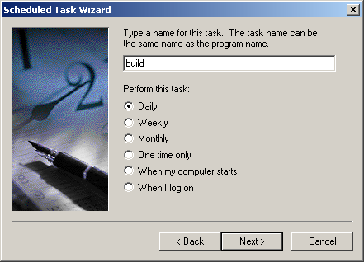
Figure 10-18. Choosing a schedule
- Select an option indicating when to run the task, and click Next. The wizard displays the time page, as shown in Figure 10-19.
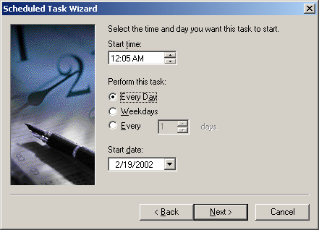
Figure 10-19. Choosing a time to run
- Enter a time to run the task, and click Next. The wizard displays the password page, as shown in Figure 10-20.
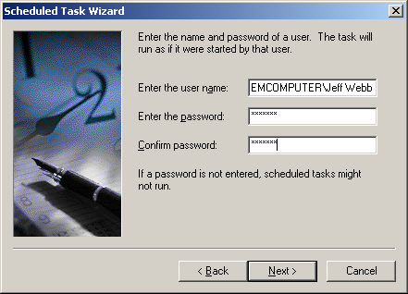
Figure 10-20. Entering user name and password
- Enter the user name and password under which to run the command, click Next, and then click Finish to complete the wizard.
Viewing Log Files
Because builds and tests scheduled with the Task Manager run unattended, it is important to monitor log files created by the commands in the build process. The build and test commands shown earlier in this section used the redirect operator (>) to write output from commands to log files stored in a Log folder.
Viewing log files in Notepad is easy, as shown in Figure 10-21.
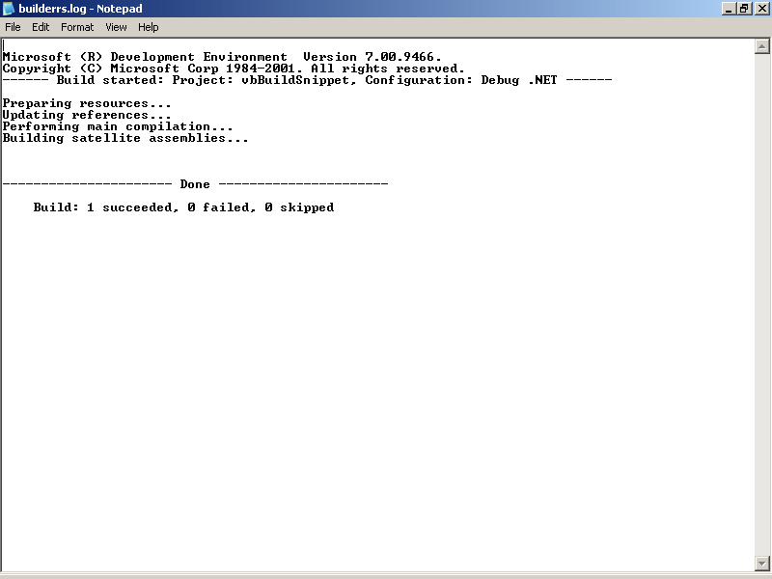
Figure 10-21. Viewing a build log
Lesson 3: Debugging
Testing is probably one of the few endeavors in which failure is a kind of success. In this lesson, you’ll learn how to use those successes to fix problems in your code. The topics covered in this lesson build on the discussion of the Visual Studio debugging tools begun in Chapter 1, “Introduction to Web Programming.” This includes fixing specific problems uncovered by testing, adding diagnostic code to an application, and debugging a Web application as it runs on a remote server.
After this lesson, you will be able to
- Apply the results of unit tests to fix common problems
- Use the Debug and Trace diagnostic classes to display alerts and generate logs during development
- Configure a Web server to allow remote workstations to debug Web applications
- Debug Web applications as they run on a remote server
Estimated lesson time: 30 minutes
Putting Test Results to Work
Something you probably noticed if you ran the unit tests for the FlashCards application shown in Lesson 1 is that FlashCards didn’t pass the tests. That’s because FlashCards is a simplified demonstration program, not a robust application intended for commercial use. Try that excuse at work sometime!
Seriously, though, the results are instructive. The first set of errors you encounter with the FlashCardClass unit tests are overflows, because you used integer MinValue and MaxValue properties to initialize the random numbers. Adding two values near the integer’s maximum value results in a number larger than an integer. The related code is shown here:
Visual Basic .NET
' Test code
Function TestFlashCard() As Boolean
'Create class
Dim FlashCard As New vbFlashCards.FlashCardClass()
'Test is class exists.
If IsNothing(FlashCard) Then
Console.WriteLine("FlashCardClass failed")
' Return false and end here.
Return False
End If
'Test shuffle method.
FlashCard.Shuffle(Integer.MinValue, Integer.MaxValue)
'Test properties.
If (FlashCard.Answer <> FlashCard.FirstNumber + FlashCard.SecondNumber) _
Then
Console.Write("Error: Answers don't match")
End If
End Function

' FlashCardClass code with error.
' Calculates answer based on current operation.
Public Function Answer() As Integer
Select Case mstrOp
Case "+"
Return mintFirstNumber + mintSecondNumber 'Overflow!!!!
Case "x", "*"
Return mintFirstNumber * mintSecondNumber
Case "-"
Return mintFirstNumber – mintSecondNumber
Case Else
Return 0
End Select
End Function
Visual C#
//Test code.
static bool TestFlashCardClass()
{
//Create class
csFlashCards.FlashCardClass FlashCard = new csFlashCards.FlashCardClass();
//Test is class exists.
if (FlashCard == null)
{
Console.WriteLine("FlashCardClass failed");
//Return false and end here.
return false;
}
//Test shuffle method using maximum and minimum values.
FlashCard.Shuffle(int.MinValue, int.MaxValue);
//Test properties.
int intFirst = FlashCard.FirstNumber;
int intSecond = FlashCard.SecondNumber;
double dblAnswer = intFirst + intSecond;
if (dblAnswer != (double)FlashCard.Answer())
{
Console.WriteLine("Error: Numbers don't add up!");
}
}

//FlashCardClass code with error.
//Calculates answer based on current operation.
public int Answer()
{
switch(mstrOp)
{
case "+":
return mintFirstNumber + mintSecondNumber;
case "x":
return mintFirstNumber * mintSecondNumber;
case "*":
return mintFirstNumber * mintSecondNumber;
case "-":
return mintFirstNumber - mintSecondNumber;
default :
return 0;
}
}
You have two ways to tackle this problem: restrict the range of possible FirstNumber and SecondNumber property values, or change the return type for the Answer method. The second approach is more obvious from a user’s standpoint because integers are a common input type and it would be hard to explain a new, smaller type for those properties.
The following code shows the changes to the Answer method that allow it to pass its unit test:
Visual Basic .NET
Public Function Answer() As Double
Select Case mstrOp
Case "+"
Return CDbl(mintFirstNumber) + CDbl(mintSecondNumber)
Case "x", "*"
Return CDbl(mintFirstNumber) * CDbl(mintSecondNumber)
Case "-"
Return CDbl(mintFirstNumber) - CDbl(mintSecondNumber)
Case "/"
Return CDbl(mintFirstNumber) / CDbl(mintSecondNumber)
Case Else
Return 0
End Select
End Function
Visual C#
public double Answer()
{
switch(mstrOp)
{
case "+":
return mintFirstNumber + mintSecondNumber;
case "x":
return mintFirstNumber * mintSecondNumber;
case "*":
return mintFirstNumber * mintSecondNumber;
case "-":
return mintFirstNumber - mintSecondNumber;
default :
return 0;
}
}
Another problem arises with FlashCardClass if you specify an Operation property other than +, -, /, * or x. The Operation property simply returns 0, which is a little sloppy. The following changes ensure that only valid operations are used:
Visual Basic .NET
Public Property Operation() As String
Get
Operation = mstrOp
End Get
Set(ByVal Value As String)
If InStr("+-/x*", Value) Then
mstrOp = Value
Else
Throw New Exception("Unrecognized operator")
End If
End Set
End Property
Visual C#
public string Operation
{
get
{
return mstrOp;
}
set
{
if (" +-/x*".IndexOf(value, 1) != 0)
mstrOp = value;
else
throw(new Exception("Unrecognized operator"));
}
}
These bug fixes illustrate how important it is to perform unit tests before checking new classes into a project. When a class is part of a larger project, it becomes much harder to locate the cause of an error.
Using the Debug and Trace Classes
The .NET Framework includes the Debug and Trace classes in the System.Diagnostics namespace as tools to help you ferret out errors and unexpected behaviors in your application. These classes let you display alerts or write messages based on results within your application.
The difference between the two classes is how they are handled in release builds. By default, Debug methods and properties are automatically stripped out of code compiled for release. Trace methods and properties are retained in release code by default. This gives you two levels of diagnostics: one for debugging errors prior to release, and one for diagnosing performance and problems in the field.
Because Debug and Trace are part of a .NET namespace, you need to add an Imports or using statement to code modules before using them:
Visual Basic .NET
Imports System.Diagnostics
Visual C#
using System.Diagnostics;
Displaying Alerts and Messages
The Debug and Trace classes’ Assert method tests a value and displays an alert if the value is False. Use Assert to halt an application for an unexpected result. For example, the following code displays an alert if the numbers shown on the FlashCards form don’t add up as expected:
Visual Basic .NET
Private Sub txtAnswer_TextChanged(ByVal sender As System.Object, _
ByVal e As System.EventArgs) Handles txtAnswer.TextChanged
If txtAnswer.Text = FlashCard.Answer Then
lblFeedback.Text = "Correct!"
Debug.Assert(CInt(txtAnswer.Text) = CInt(lblFirst.Text) + _
CInt(lblSecond.Text), "Form values don't add up!")
' Get another set of numbers.
FlashCard.Shuffle()
' Refresh display to show new numbers.
RefreshDisplay()
' Clear answer
txtAnswer.Text = ""
Else
lblFeedback.Text = "Oops! Try Again."
End If
End Sub
Visual C#
private void txtAnswer_TextChanged(object sender, System.EventArgs e)
{
if(txtAnswer.Text == FlashCard.Answer().ToString())
{
lblFeedback.Text = "Correct!";
Debug.Assert(Convert.ToInt32(txtAnswer.Text) ==
Convert.ToInt32(lblFirst.Text) +
Convert.ToInt32(lblSecond.Text),
"Form values don't add up!");
//Get another set of numbers.
FlashCard.Shuffle();
//Refresh display to show new numbers.
RefreshDisplay();
//Clear answer
txtAnswer.Text = "";
}
else
{
lblFeedback.Text = "Oops! Try Again.";
}
}
In a Web application, the alert is displayed on the server. If you’re running the Web application’s server on your local machine, this alert appears as expected, as shown in Figure 10-22. If you’re running the Web application on a remote server, however, you won’t see the alert if you’re attached to the application’s process running on the server only for remote debugging, as described later in this lesson.
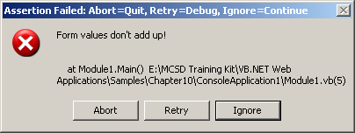
Figure 10-22. Displaying an alert (local server)
Use the Write or WriteLine methods to write a message without halting the application. By default, these messages are displayed in the Visual Studio .NET Output window during debugging.
Logging Debug and Trace Messages
To record debug and trace messages on a deployed application, create a TextWriterTraceListener class and add it to the Debug or Trace class’s Listeners collection. For example, the following code directs debug messages to the server’s console:
Visual Basic .NET
Debug.Listeners.Add(New TextWriterTraceListener(Console.Out))
Debug.WriteLine("Starting tests.")
Visual C#
Debug.Listeners.Add(new TextWriterTraceListener(Console.Out));
Debug.WriteLine("Starting tests.");
To write messages to a file rather than to the console, specify a file name and use the Flush method to write the output. For example, the following code writes a message to the Results.log file:
Visual Basic .NET
Debug.Listeners.Add(New TextWriterTraceListener("Results.log"))
Debug.WriteLine("Starting tests.")
Debug.Flush()
Visual C#
Debug.Listeners.Add(new TextWriterTraceListener("Results.log"));
Debug.WriteLine("Starting tests.");
Debug.Flush();
Remote Debugging
You usually debug a Web application by running the code locally on your development machine, but that’s not the environment in which the application ultimately runs. To resolve problems with Web applications in real-world situations, you need to be able to debug them as they run on a remote server.
To debug an application on a remote server, follow these steps:
- Install the Visual Studio .NET remote debugging server components on the Web application server.
- Configure the server permissions to allow you to debug applications remotely.
- Attach to the remote Web application process from your debug machine.
The following sections describe these steps in greater detail.
Installing Remote Components
The Visual Studio .NET Setup Wizard includes an option for installing remote components. Run Visual Studio .NET Setup on the server, and choose the Full Remote Debugging option during installation, as shown in Figure 10-23.
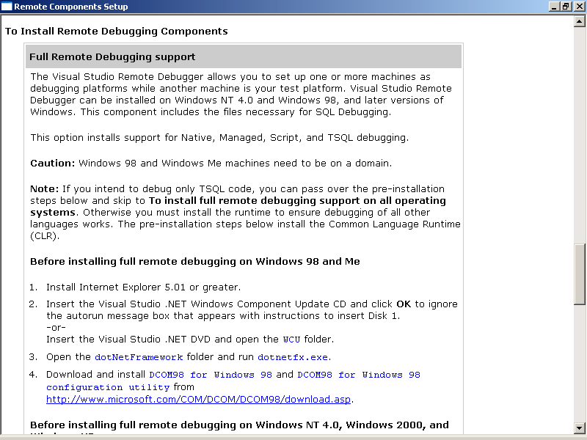
Figure 10-23. Installing remote debugging components
Setup installs the required components and configures the server to allow remote debugging.
Setting Server Permissions
To be able to debug processes running on a server, you must have a user account on the server and that account must belong to the Debugger Users group. The Visual Studio .NET Setup Wizard creates this group when you install the remote debugging components. You should make sure that all users who need debugging privileges on the server belong to this group.
Use the MMC to add users to this group, as shown in Figure 10-24.
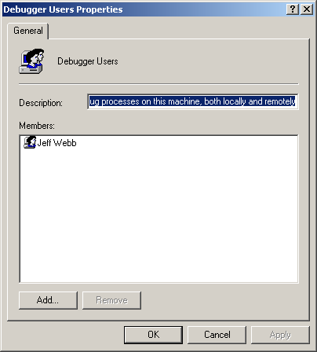
Figure 10-24. Adding remote debugger users
Attaching to a Remote Process
Visual Studio .NET can attach to processes running on a remote server. While attached to the process, Visual Studio .NET can receive Output window messages, display alerts from the Assert method, set breakpoints, view variables, and step through code running on the remote server.
To attach to a remote process, follow these steps:
- From the Tools menu, choose Debug Processes. Visual Studio .NET displays the Processes dialog box, as shown in Figure 10-25.
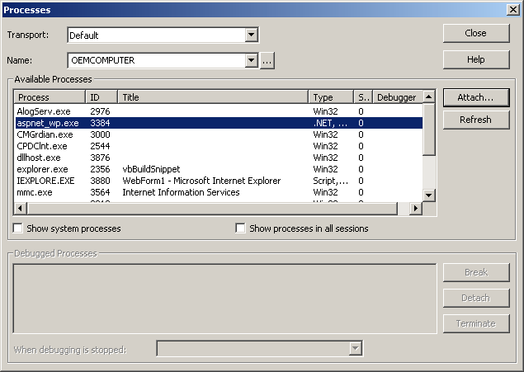
Figure 10-25. Attaching to a process
- By default, Web applications run in the process named aspnet_wp.exe. Select the remote process you want to debug, click Attach, and then click Close.
When attached to a remote process, Visual Studio .NET can step into the code by setting breakpoints. The easiest way to do this with a Web application is to set a breakpoint for the Page_Load function to halt the application at the beginning of a Web form and then set breakpoints or watches within the remote code as desired.
To set a breakpoint in a remote process, follow these steps:
- Click the Breakpoints tab in Visual Studio .NET, as shown in Figure 10-26.
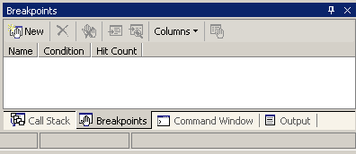
Figure 10-26. Breakpoints window
- Click the New button on the Breakpoints window toolbar. Visual Studio .NET displays the New Breakpoint dialog box, as shown in Figure 10-27.
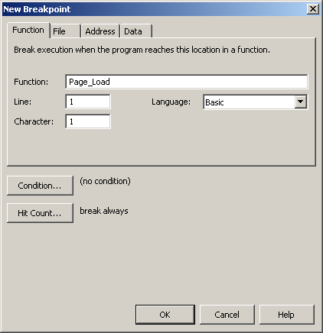
Figure 10-27. Adding a breakpoint
- Enter a procedure name in the Function box, and click OK. For Web applications, it’s easiest to stop the application at the Page_Load event procedure and then set additional breakpoints as required.
When a remote process is stopped at a breakpoint, you can use Visual Studio .NET’s debugging tools to view variables, step through code, or execute commands as you would with a local process.
Summary
- Testing measures conformance to product requirements.
- Unit tests check that each piece of code works correctly.
- Integration tests verify that all components work together.
- Regression tests make sure that new code does not break existing code.
- Load tests check that the product works under extreme usage.
- Platform tests make sure that a Web application is displayed correctly and has reasonable performance using different browser and network connection configurations.
- Use ACT to record user interaction with a Web application in VBScript, and then replay that script to simulate multiple users and log application errors and server performance.
- To test a .NET assembly with the Windows Scripting Host, register the assembly for use with COM, and then copy the scripting host (CScript.exe) to the assembly’s folder.
- To run attended builds and tests, create a command file containing the build commands to execute and test scripts to run, and then schedule the command file to run using the Windows Task Scheduler.
- Use the Debug and Trace diagnostic classes to display alerts and log error conditions during the development process.
- By default, code written with the Debug class is stripped out of release builds, and code using the Trace class is left in.
- Visual Studio .NET can attach to the process of a Web application running on a remote server to debug that application in a real-world setting.
Lab: Testing and Debugging
In this lab, you’ll apply the lessons from this chapter to review a real-world testing plan, write unit tests for a sample application, load test a deployed application, and step through a Web application running on a remote server using the Visual Studio .NET debugging tools.
Estimated lesson time: 30 minutes
Exercise 1: Review a Test Plan

Testing strategies and terminology vary from company to company. In this exercise, you’ll use a test plan from your own company to identify the concepts discussed in Lesson 1. If you don’t work for a company that uses test plan documents, search the Internet using the phrase software test plan, and choose a test plan from the search results.
Using an actual test plan, highlight any mention of the following items:
- Unit testing
- Integration testing
- Ad hoc testing
See whether you can find answers to the questions posed in Lesson 1:
- How are tests written?
- Who is responsible for the testing?
- When are the tests performed?
- Where are the tests and test results stored?
- What is being tested?
Based on this information, does the plan give you a clear idea of how testing will verify that the product requirements are met?
Exercise 2: Write Unit Tests
In this exercise, you’ll use VBScript or JScript to create unit tests for the Circle and Sphere classes that were derived from the Shapes abstract class in Chapter 3, “Working with Web Objects.” The unit tests should verify that the following conditions are met:
- Circle and Sphere classes can be created.
- Classes can be passed to procedures accepting the IFigure interface.
- All properties work with minimum and maximum values.
- All methods return expected results for two or more test cases.
To create unit tests in VBScript or JScript
- Register the assembly for use with COM by running the RegAsm.exe utility from the Visual Studio .NET command prompt.
- Copy the Windows Scripting Host (CScript.exe) to the folder containing the assembly to test.
- Using Visual Studio .NET, Notepad, or some other editor, create the tests in VBScript or JScript.
- Run the scripts from the Visual Studio .NET command prompt using the copy of CScript.exe in the assembly folder.
When you have finished, compare your results to those found in the sample files on the companion CD.
Exercise 3: Create a Load Test
If you have Visual Studio .NET Enterprise Architect, use ACT to create a load test for a Web application that has been deployed to a test server. Choose any deployed Web application that you want, but follow these test parameters:
- Record at least five different requests to the server.
- Add performance counters for the server’s percentage of processor time, memory pages per second, and average disk read queue length.
- Log the results to a Log folder within the Web application’s folder structure.
- Set the test properties to run for 30 seconds using four simultaneous connections.
- Run the test.
- View the performance counters for the server in chart form within ACT.
When you have finished, compare your results to the ACT sample recorded for the FlashCards sample application on the companion CD.
Exercise 4: Step Through a Remote Process
In this exercise, you’ll use Visual Studio .NET to pause and step through a Web application running on a remote server. To complete this exercise, you must belong to the Debugger Users group on the server and the server must have the Visual Studio .NET remote components installed.
To step through a Web application running on a remote server
- From your workstation, access the Web application using Microsoft Internet Explorer. This ensures that the Web application is running on the server when you try to attach to its process.
- From the Visual Studio .NET Tools menu, choose Debug Processes. Select the server where the application is running, select the application’s process (named aspnet_wp.exe), and then click Attach.
- Set a breakpoint on the Page_Load function.
- Switch to Internet Explorer, and click Refresh.
- Switch back to Visual Studio .NET. The remote application should be paused at Page_Load.
- Set breakpoints at other locations in code.
- In Visual Studio .NET, click Continue to run to the next breakpoint.
Review
The following questions are intended to reinforce key information presented in this chapter. If you are unable to answer a question, review the appropriate lesson and then try the question again. Answers to the questions can be found in the appendix.
- How do unit, integration, and regression testing relate to each other?
- Why is load testing likely to be more important for a Web application than for a standalone Windows application?
- What is the difference between the Debug and Trace classes?
- What are the two special steps you need to take to ensure that a COM component can use a component from a .NET assembly?

